Ryan A Peguero
CS - 255

System Components and Design

Purpose
What is the purpose of this project? Who is the client and what do they want their system to be able to do?
DriverPass aims to reduce driving test failures by providing students with online practice exams and on-the-road training. The system will centralize access for students, instructors, and administrators to manage schedules, track progress, and ensure compliance with DMV regulations (Valacich & George, 2025).

System Background
What does DriverPass want the system to do? What is the problem they want to fix? What are the different components needed for this system?
The problem DriverPass wants to fix is the 65% of students fail driving tests due to inadequate preparation tools.
Key components needed for this system are:
- Role-based authentication such as students, instructors and admins.
- Online exam modules with real-time grading and DMV-aligned content.
- Scheduling system for driving lessons (three packages with customizable session lengths).
- Activity logs for tracking reservations, cancellations, and modifications (Satzinger et al., 2023)

Objectives and Goals
What should this system be able to do when it is completed? What measurable tasks need to be included in the system design to achieve this?

The goal of this system when it’s completed is to make sure these things are achievable:
- Reduce exam failure rates by 40% within one year.

- Ensure 99% system uptime for uninterrupted access (Valacich & George, 2025).

- Enable admins to disable outdated training packages without developer intervention (Satzinger et al., 2023).

Requirements

Nonfunctional Requirements
In this section, you will detail the different nonfunctional requirements for the DriverPass system. You will need to think about the different things that the system needs to function properly.

Performance Requirements
What environments (web-based, application, etc.) does this system need to run in? How fast should the system run? How often should the system be updated?

- Web-based platform accessible via different browsers such as Firefox, Chrome, Safari etc, and mobile devices.
- Less than 2 seconds response time for exam submissions and scheduling updates (Valacich & George, 2025).

Platform Constraints
What platforms (Windows, Unix, etc.) should the system run on? Does the back end require any tools, such as a database, to support this application?

Some platform constraints are:

- Cloud-hosted like AWS or Azure for automated backups and scalability.

- Backend database like PostgreSQL to store user data, exam results, and session logs (Satzinger et al., 2023).

Accuracy and Precision
How will you distinguish between different users? Is the input case-sensitive? When should the system inform the admin of a problem?

- Usernames are case-insensitive, example: "User123" = "user123"), while passwords are case-sensitive to enhance security (Valacich & George, 2025).

- The system shall log all reservation modifications such as cancellations or rescheduling with timestamps and user IDs for audit trails which are Liam’s requirement for activity reports.

- Admins receive real-time alerts for system errors like database connection failures to ensure data integrity (Satzinger et al., 2023).

Adaptability
Can you make changes to the user (add/remove/modify) without changing code? How will the system adapt to platform updates? What type of access does the IT admin need?

- Admins can disable training packages like Package One via a dashboard without developer intervention from Liam’s requirement for flexibility.

- Modular architecture allows integration of future DMV policy updates like new exam questions via API notifications (Valacich & George, 2025).

- The cloud-based platform AWS and Azure supports scalability to accommodate increased user traffic during peak registration periods (Satzinger et al., 2023).

Security
What is required for the user to log in? How can you secure the connection or the data exchange between the client and the server? What should happen to the account if there is a “brute force” hacking attempt? What happens if the user forgets their password?

- Multi-factor authentication or MFA for admin accounts which is one of Ian’s requirements.
- Account lockout after 3 failed login attempts to prevent brute-force attacks.
- Password reset via email or SMS (Valacich & George, 2025).

Functional Requirements
Using the information from the scenario, think about the different functions the system needs to provide. Each of your bullets should start with “The system shall . . .” For example, one functional requirement might be, “The system shall validate user credentials when logging in.”

- The system shall validate user credentials and assign role-based permissions student, instructor, and admin.
- The system should allow students to schedule, modify, or cancel driving lessons via an online calendar.
- The system also should generate PDF reports for instructors showing student progress and driver comments (Valacich & George, 2025).

User Interface
What are the needs of the interface? Who are the different users for this interface? What will each user need to be able to do through the interface? How will the user interact with the interface (mobile, browser, etc.)?

- Students:
  - Dashboard with exam history, scheduled lessons, and pickup/drop-off locations.
  - Mobile-responsive design for on-the-go access referencing Liam’s sketch.
- Instructors:
  - Interface to submit session notes like “Driver Comments” table.
  - Real-time access to student performance analytics.
- Admins:
  - Tools to manage user accounts, disable packages, and monitor activity logs (Satzinger et al., 2023).

Assumptions
What things were not specifically addressed in your design above? What assumptions are you making in your design about the users or the technology they have?

- DMV policy updates will be provided via API integration.
- Third-party payment gateways such as Stripe handle credit card transactions.

Limitations
Any system you build will naturally have limitations. What limitations do you see in your system design? What limitations do you have as far as resources, time, budget, or technology?

- No offline functionality for scheduling or exams which is Sam’s clarification.

- Customizing packages such as adding VR training requires developer intervention (Valacich & George, 2025).

Gantt Chart
Please include a screenshot of the GANTT chart that you created with Lucidchart. Be sure to check that it meets the plan described by the characters in the interview.
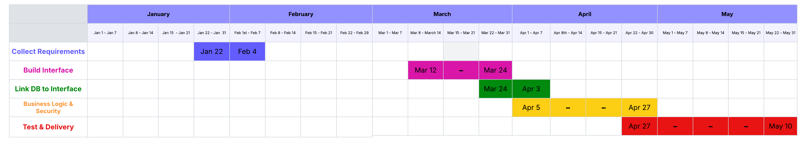

References
Valacich, J., & George, J. (2025). Modern Systems Analysis and Design (10th ed.). Pearson.
Satzinger, J. W., Jackson, R. B., & Burd, S. D. (2023). Systems Analysis and Design in a Changing World (8th ed.). Cengage Learning.

